

Summary of Consultations relating to Tapawera’s Community Hub

Contents and Results Snapshot:

Page 2: 2024 Feasibility Study undertaken by Robyn Steele of RSLC Consultancy
Scope: 2 Community meetings attended by around 40 individuals, a meeting with 10 youth at the school, 18 face to face meetings with key stakeholders and community facility owners
Conclusion: This report has found that there is sufficient need for a fit-for-purpose community centre in Tapawera.

Page 3: 2024 Tapawera Community Plan Consultation
Scope: 130 respondents (7% of the Golden Downs Statistical Area)
Conclusion: Of those 130 respondents, 114 (88%) supported the hub as a priority

Page 4: 2020 Tapawera Connect Community Survey
Scope: 80 respondents (4% of the Golden Downs Statistical Area) & discussions with participants at the following 5 Summer Workshops (between 5-20 participants at each workshop).
Conclusion: 65 respondents thought Tapawera needed a new hub, 8 said no, and 5 didn’t know.

Page 6: Other Consultations:
Meeting with all Tapawera Area School staff
2015 TDCC Community Consultations

Page 7: The Golden Downs Statistical Area

Feasibility Study 2024 - Consultant: Robyn Steele, RSLC:

Consultation Scope:
2 Community meetings attended by around 40 individuals,
A meeting with 10 youth at the school,
18 face to face meetings with key stakeholders and community facility owners

‘Conclusion
This report has found that:
1. There is sufficient need for a fit-for-purpose community centre in Tapawera that allows for the integration of current community activity and services and creates a connection space for the community.’

The full report can be read on our community website here:
https://Welcome to Tapawera Community | Tapawera Community

2024 Community Plan Consultation:

114 of 130 respondents supported the Community Hub (88%), with ‘Advocating for increased health services including family and mental health’ having the highest ‘high priority’ rating overall.
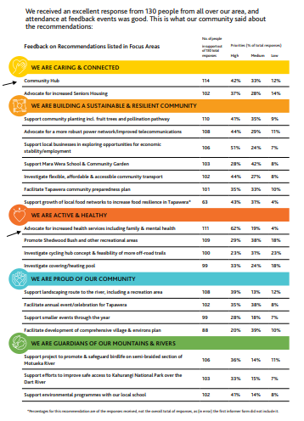

2020 Tapawera Connect Community Survey:

65 out of 80 respondents replied ‘Yes’ when asked if they thought Tapawera would benefit from a Community Hub.
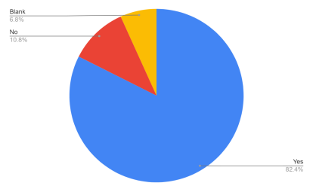
This is what they said they would like to see in one:

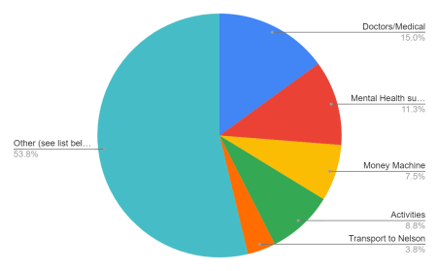

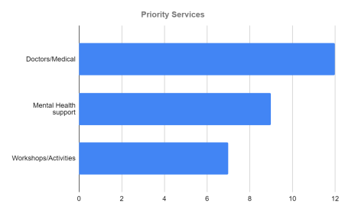

What community members would like to see in a hub:
A welcoming space to connect, hold workshops and events and drop in and catch up llll llll llll llll llll llll llll llll llll llll llll llll I
A space for children and teenagers llll llll
A place to go to get out of the house
A one stop shop- social and medical services and support
Central point for local information lll
Wifi/Computers lll
Interest/Hobby groups to connect lll
Dedicated space for services (Doctors/Medical, Mental Health and Welfare support) llll llll llll llll llll llll
Parenting Support llll llll llll llll
Budget Support llll lll
WINZ llll lll
Information and support (for locals and visitors) llll llll llll I
Support for elderly llll llll ll
Rural Men’s Support llll lll
Movie nights llll llll llll llll ll
Youth Group run from a hub llll llll llll llll llll ll

Other Consultations: Summary of Results

Need Identified: | Source: | Date:
Counselling | Tapawera School Staff (at staff meeting, discussion facilitated by Phoebe) | 26 Aug 2020
Mental Health Support |  | 26 Aug 2020
Family Support/Parent  Education |  | 26 Aug 2020
Family Law Support |  | 26 Aug 2020

Youth Group 15+  5pm-10pm Wed, Fri and Sat  Youth Group 12-14 yr olds 3:30-5pm  Food, pool, darts, speakers, couches | TDCC Youth Consult | Nov 2015
Movie nights | TDCC Youth Consult | Nov 2015
Information kiosk  Improved Noticeboards | TDCC Community  Consultation | 2015
Community Information  Facility  Comprehensive list of  groups/activities/meeting times etc in an obvious place  Register of skills and services in the area with contact details  Community Facilitator | TDCC Community  Consultation | 2015

The Golden Downs Statistical Area:

